# Image 1 - A boy is sitting against a tree, smiling, and looking at the screen of a laptop. His arms are raised. Graphic - Bookshare logo in a orange box. Image 2 - A man is looking intently at a tablet screen.How to Guide

# Read with Bookshare

# Reader for Web

**Welcome to the Bookshare Reader, a free app that allows members to read quickly and easily. This guide demonstrates how to use Bookshare Reader in an Internet browser without downloading software or book files on these recommended browsers:**

* Google Chrome version 97 and above
* Chromebooks version 105 and above
* Microsoft Edge version 110 and above
* Safari version 15.1 and above
* Mozilla Firefox version 90 and above

**Additionally, the new Bookshare Reader has exciting new features such as** Multiple bookmarks, Remember customized settings, Synching between devices, and Math ML support.

## Read with Bookshare Reader

Log into your [Bookshare](http://www.bookshare.org) account.

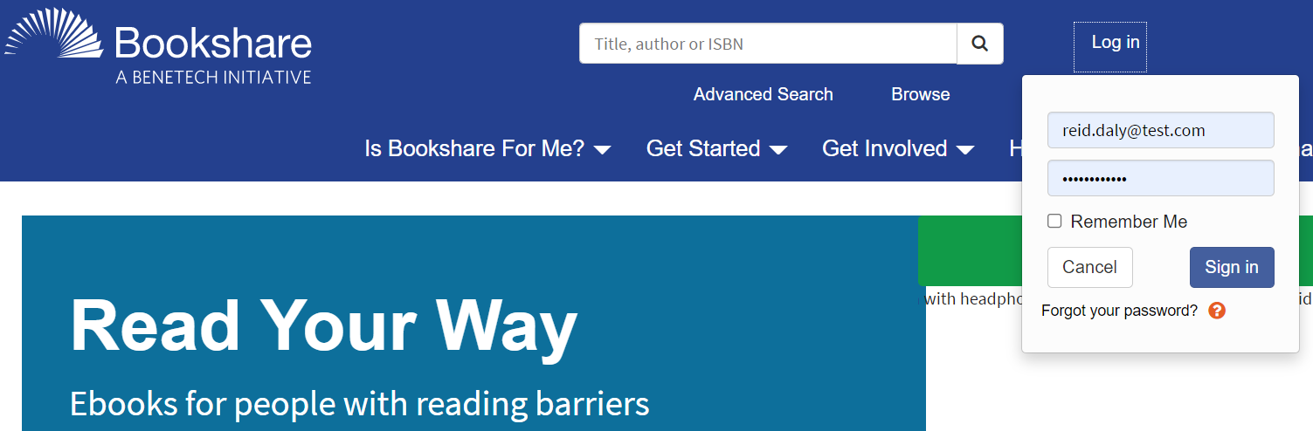

**Find a book to read!** Search for a book using the search box, Advanced Search, or Browse. You can also click on the **“My Bookshare”** link to find assigned books for students, Reading Lists, or recently read books. **NOTE:** Students who are part of a school account can only read books that are assigned to them by a teacher. Students with an individual account can read any books they choose.



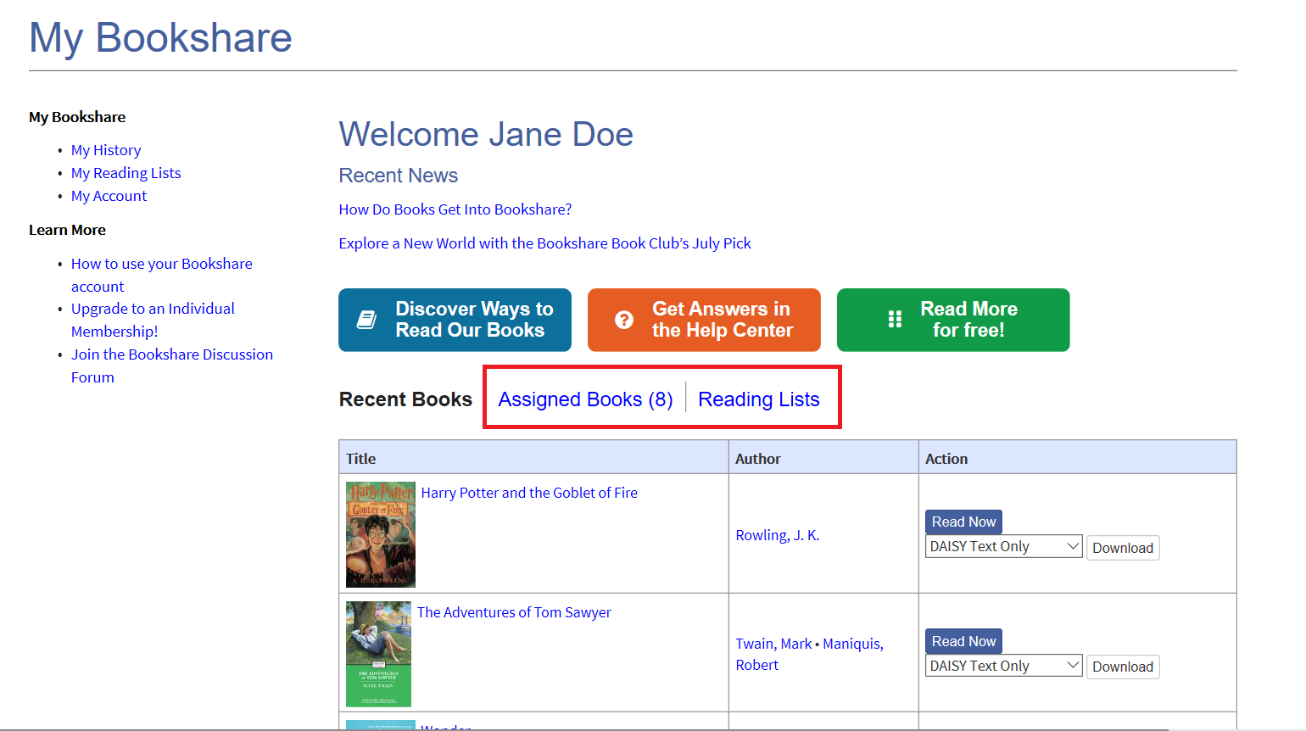

After you find the book you want to read, select the **“Read Now”** button to open the book.

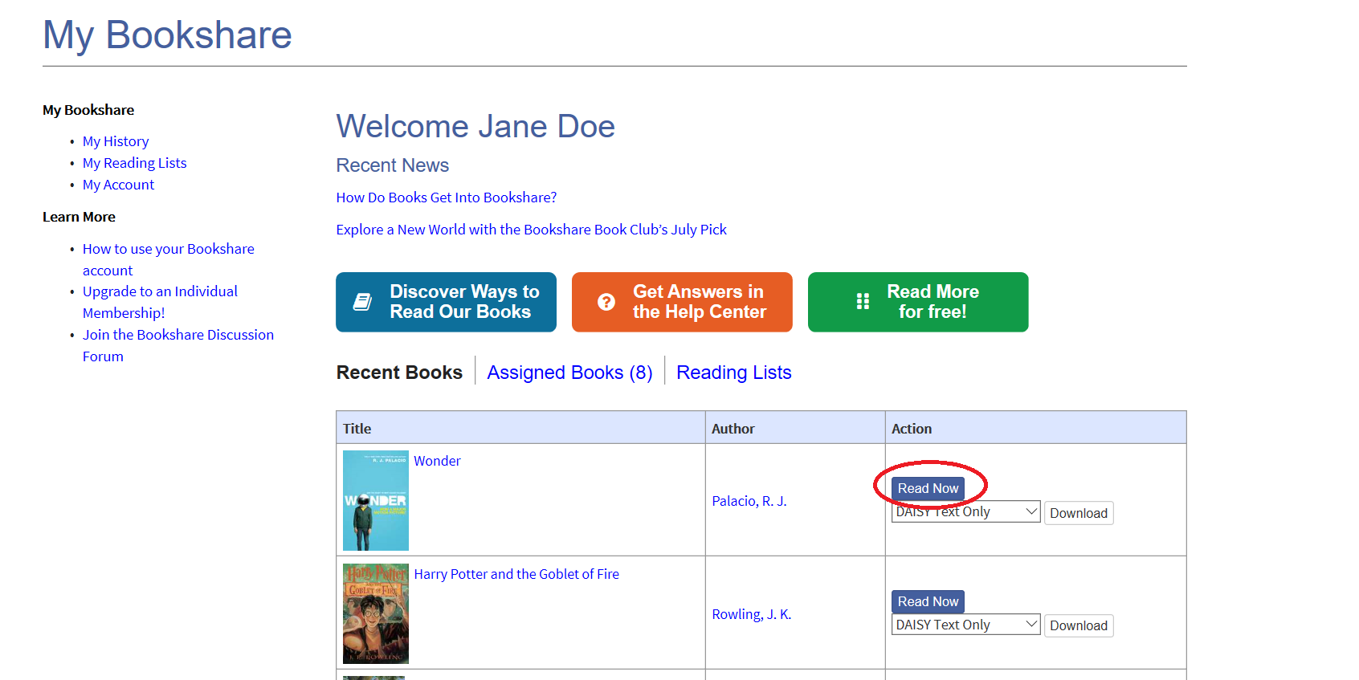

The book will open in your browser, and you can select Play to begin reading.

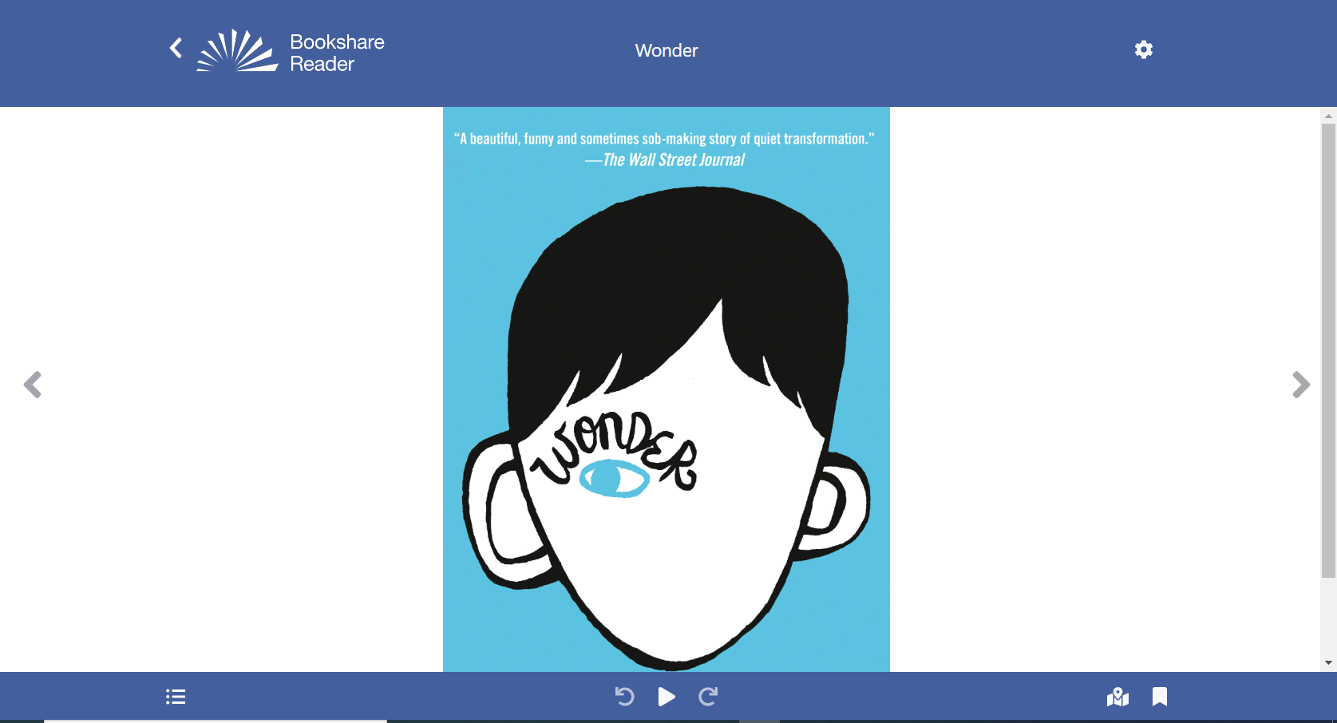

## Customization:

Use the **settings button (gear icon)** to customize audio, text, page, and color settings to your reading style and preference.



Choose **“Quick Set”** to customize key settings in real time. You can revert to default settings by selecting the **“Reset to Defaults”** button.

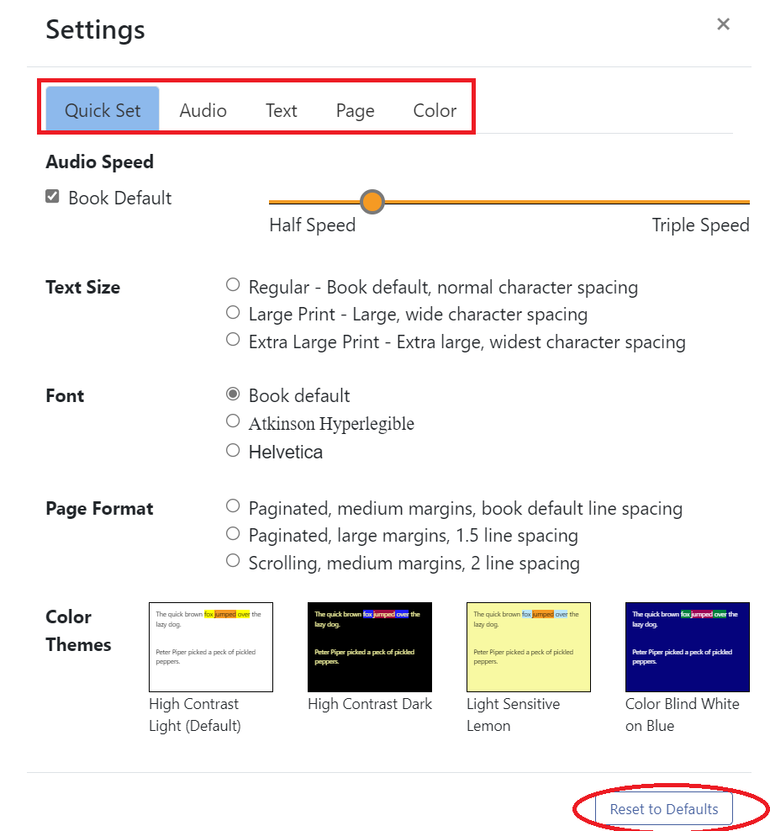

Under the **“Audio”** tab you can select a voice using the drop-down menu and adjust speed and chose voicing options. The voices available to you depend on the browser and device you are using.

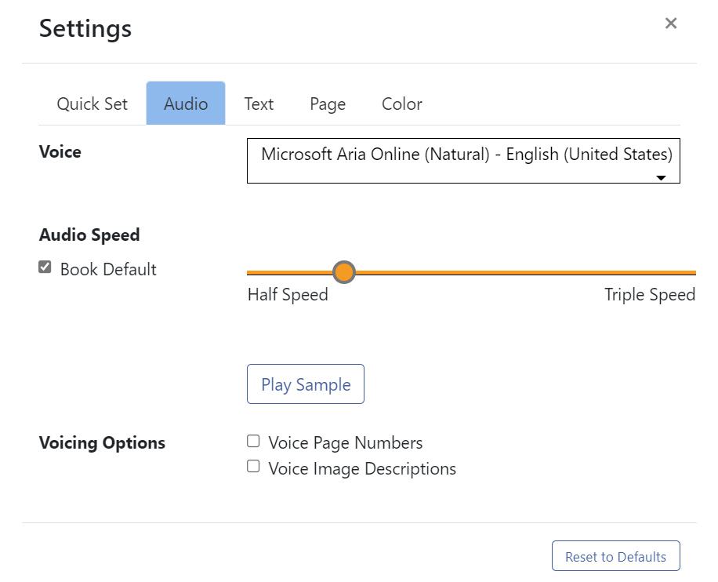

Under the **“Text”** tab you can select font size, a variety of fonts and character spacing.

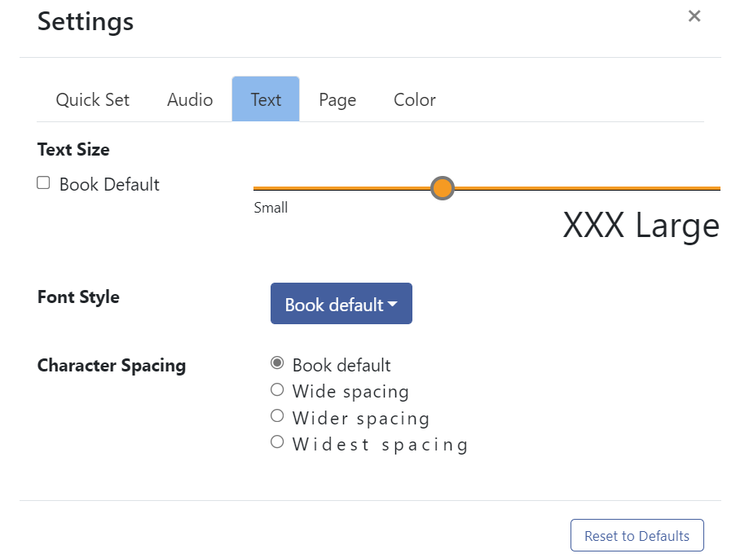

Under the “**Page”** tab you can select display format, margins and line spacing.

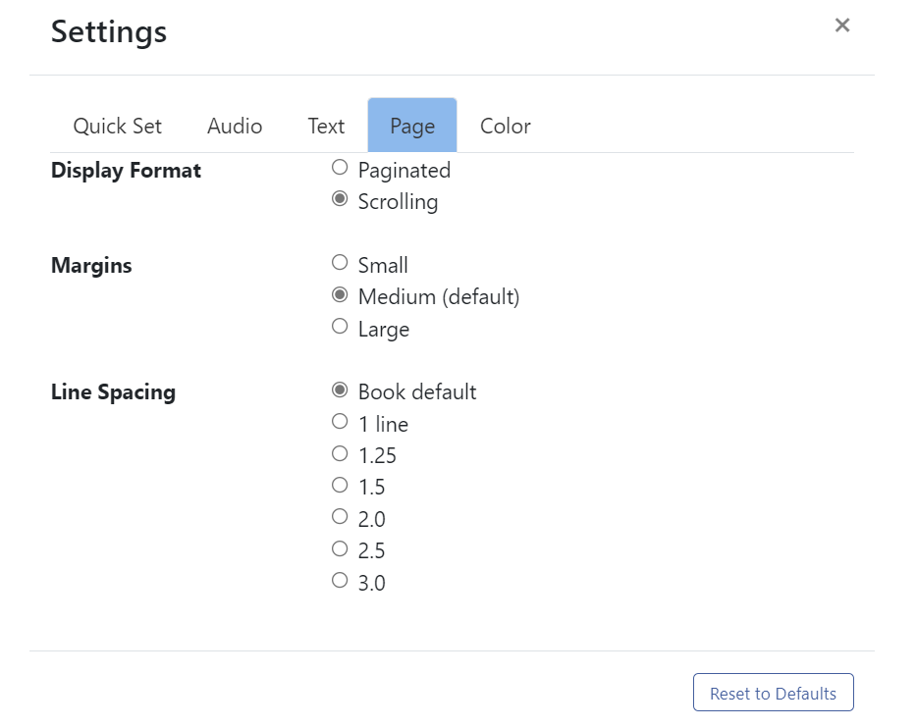

Under the **“Color**” tab you can select from a variety of preset color and contrast options or customize your own by selecting background, text, sentence highlight, and word highlight colors. **This is the last customizable category in settings**.

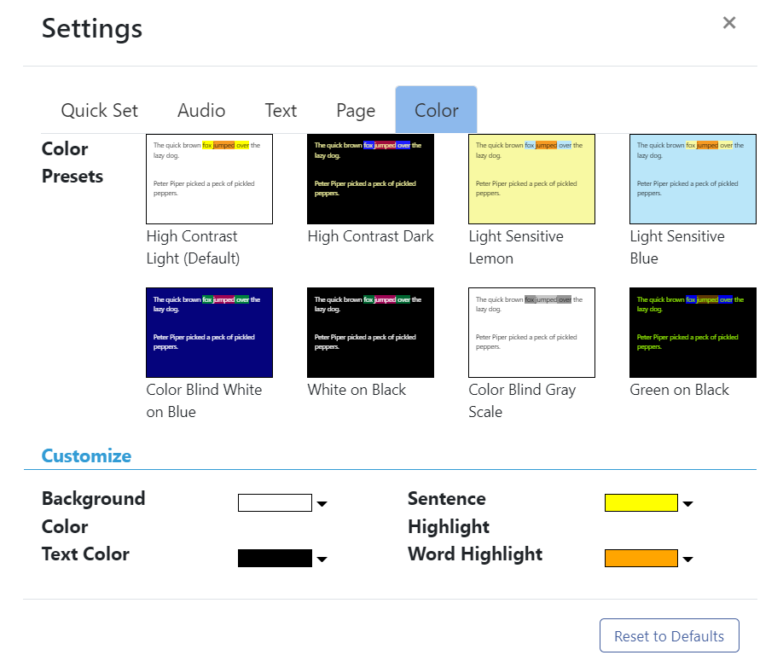

Get Reading!

The Play icon  allows you to hear the book read out loud. The arrows move the cursor back or forward one sentence. You can begin reading anywhere on the page. Simply double click where you want to start!

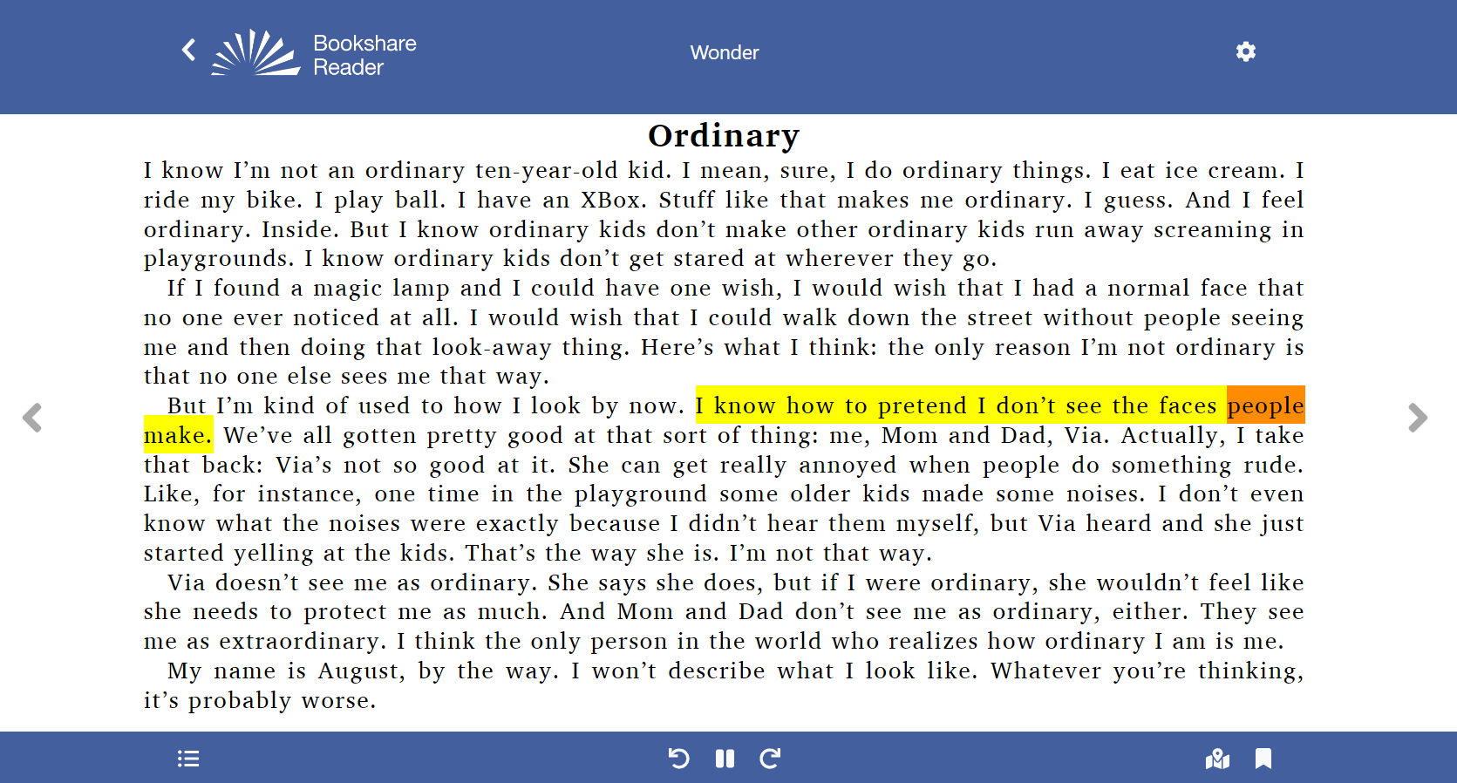

The “**Table of Contents”** icon icon bulleted list.  allows you to navigate through the book.

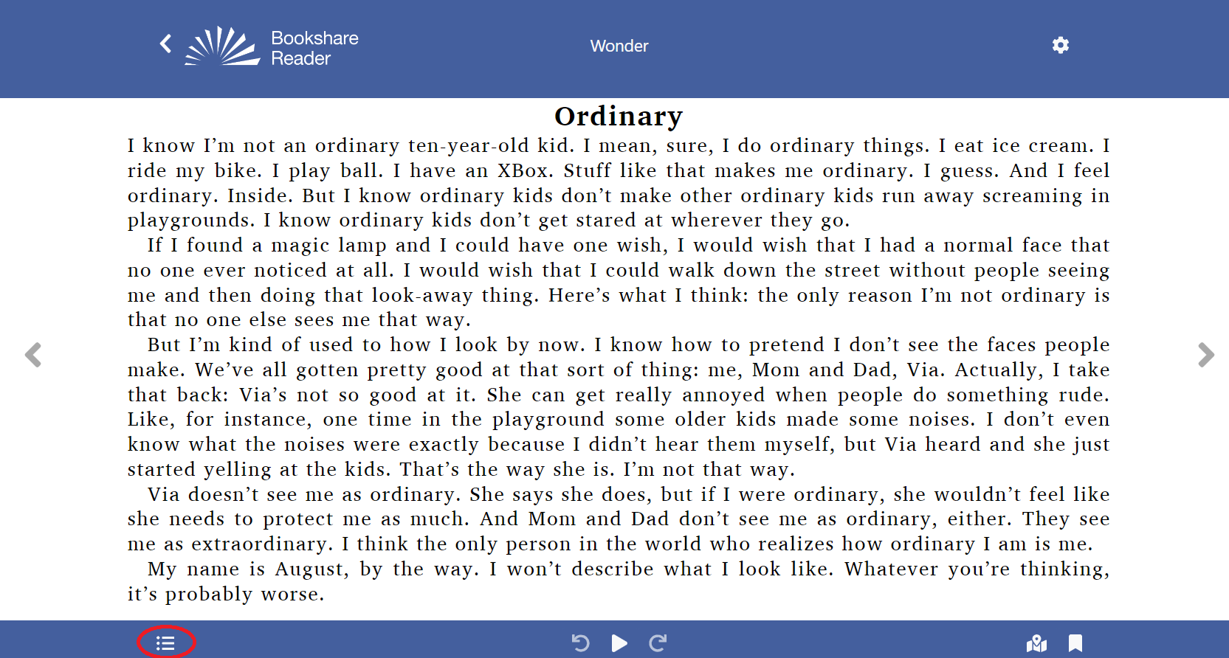

You can also navigate by page number.

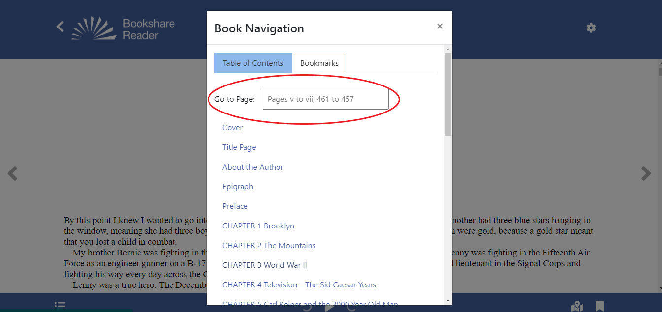

The Bookmarks icon icon bookmark. allows you to insert a bookmark to remember where you left off. You visually see an orange bookmark indicator appear.

You can utilize multiple bookmarks on a page, by selected the **“Table of Contents Icon”,** and selecting **“Bookmarks”.**

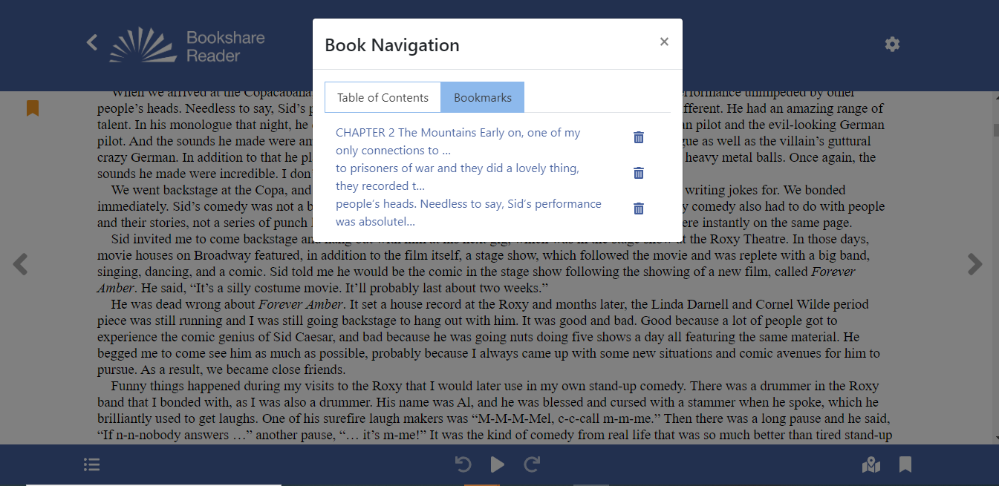

The location icon icon map  shows the reader the section you are in, relative to the entire book.

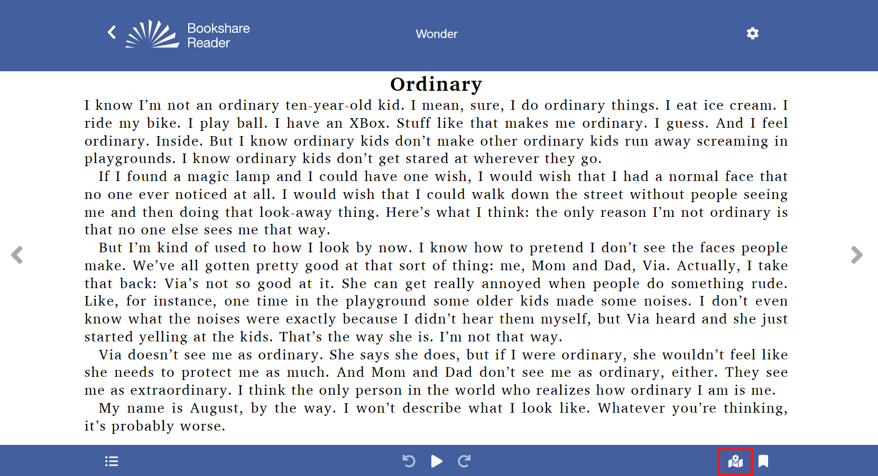

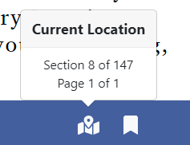

**Thank you for choosing Bookshare Reader! If you would like to learn more, please visit** **our** [**Help and Learning Center**](http://ec2-35-175-146-35.compute-1.amazonaws.com/wp-admin/post.php?post=913&action=edit)